**I. Project Description:**

Trisakay is a tricycle riding app that allows both drivers and passengers to have a more convenient experience when it comes to commuting. For drivers, the app should allow them to more easily locate potential passengers along their chosen route. For passengers, the app should allow them to quickly identify drivers in their area that are along their chosen route so that they can more easily catch a ride. Overall, it should improve local commuting experiences for both drivers and passengers in subdivisions that have available tricycle riders in them.

**II. Requirements Summary:**

The following key requirements will be taken into consideration for the development of this project:

1. **User Centric Design –** The app should have a pleasant and visually appealing design that makes it easier for users to look at, while also making sure that the design is not too distracting.
2. **Easy-to-use Interface –** The app should be straightforward to ensure that users do not have a hard time navigating the app.
3. **Real-time Notifications –** The app should be able to relay information in real-time for all users.
4. **Intuitive User Experience –** The app should be made so that it does not confuse both a driver’s and a passenger’s perception of their current location.

**III. Prototype Description:**

The Prototype was created with the use of Canva. This is because Canva is a graphic design platform that provides tools for creating social media graphics, presentations, promotional merchandise and websites.

**TriSakay Canva Link**:

https://www.canva.com/design/DAGHFUeH87c/BKOiM_hmmMc3piP72qUMxA/view?mode=prototype#notifications-page

**User Scenario:**

An elderly couple living in a neighborhood not too far from the barangay market, needs to buy food. Tricycles are the best choice since the location of the market is just within their barangay, which means they won’t need a large vehicle for transportation. But usually, no tricycles enter their neighborhood, leaving the couple with no ride. At the same time, if they were to walk to the subdivision gate (where people usually grab a ride), it is on the other hand also too far for them to walk. But they remember an app introduced to them by a fellow neighbor, called TriSakay, that’ll indeed help solve their catastrophic tricycle problem.

Using the app, tapping in for a tricycle and notifying in the app that they would need a ride to the market, then comes a tricycle driver who successfully gets the notification and picks them up. Using TriSakay helped the couple notify they need a ride, get picked up, be brought to the market and be brought back home safely with all their goods bought.

**TriSakay Prototype**:

 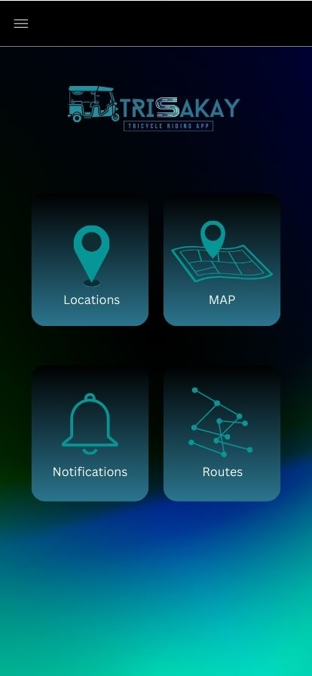 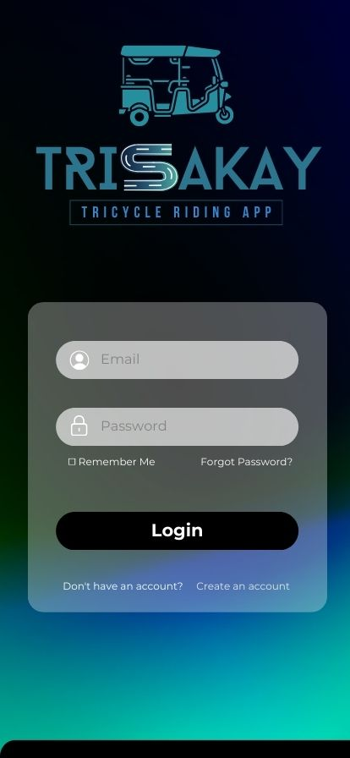

**Splash Screen**   **Main Menu**  **Login Screen**

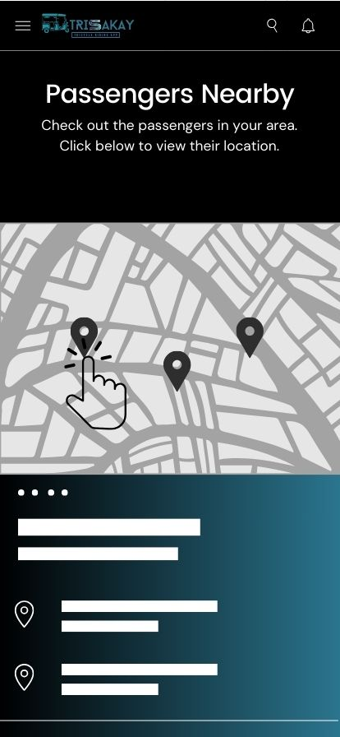 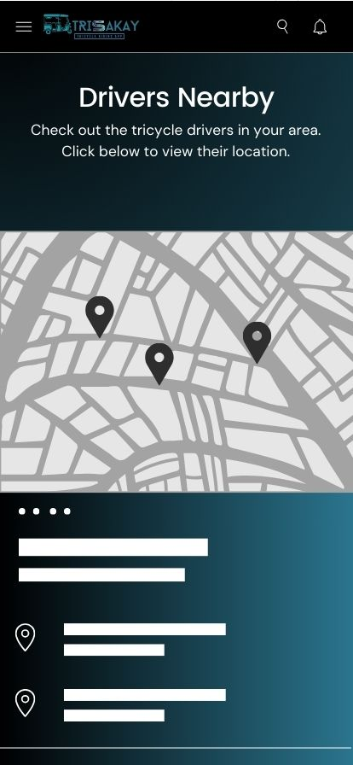 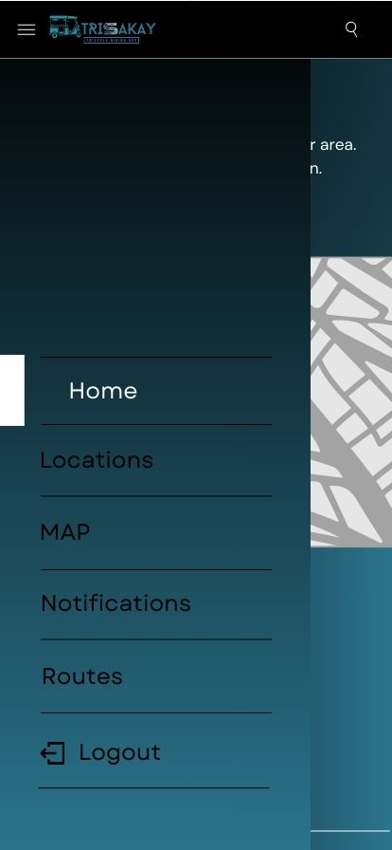

**User (Driver)**  **User (Passenger)**   **Menu Bar**

**Prototype Flow**:

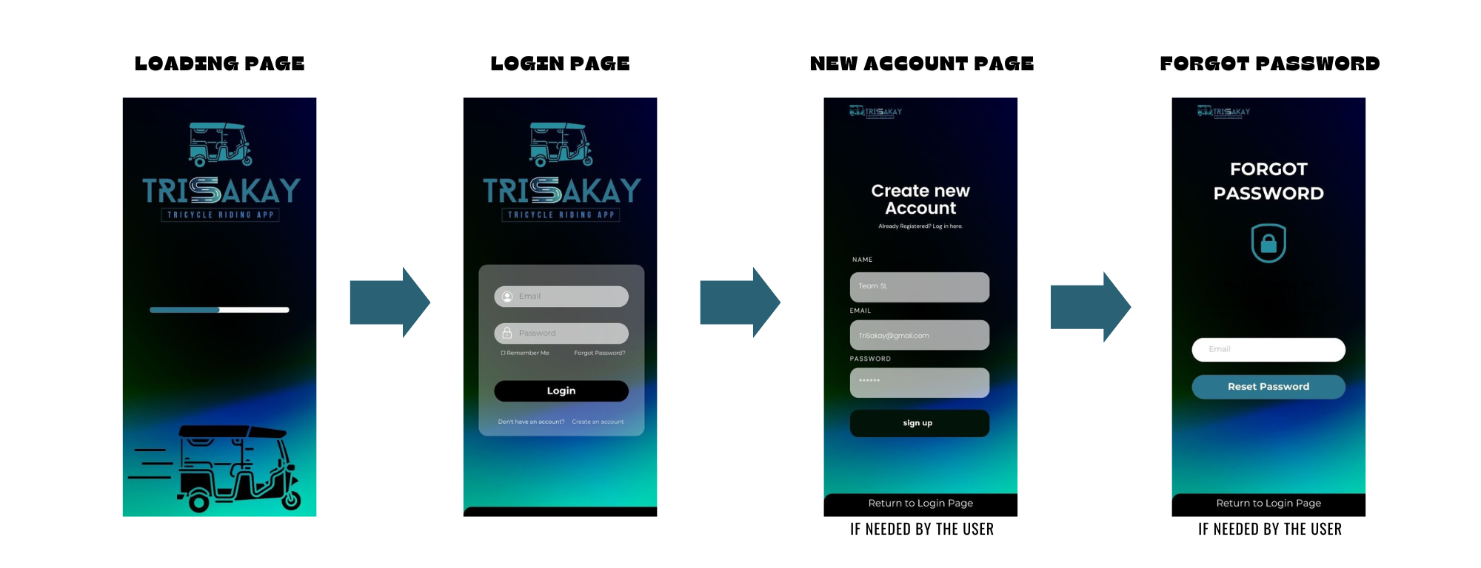

**Figure 1. -** *Figure 1 shows the process of what a user undergoes once the application has been opened. From the loading screen to the login/new account/forgot password pages.*

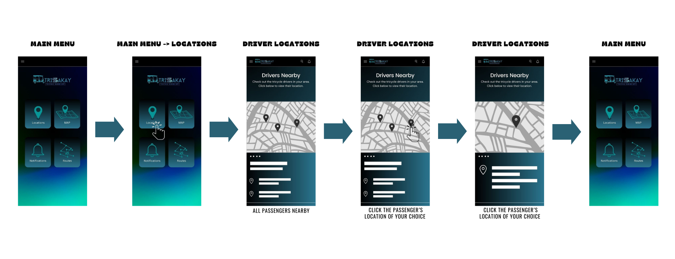**Figure 2. -** *Figure 2 shows the process of what a user undergoes from after logging into the app. The main menu screen is then in view by the user and once they click on locations, it will either show the broad and specific locations of drivers nearby or passengers nearby.*

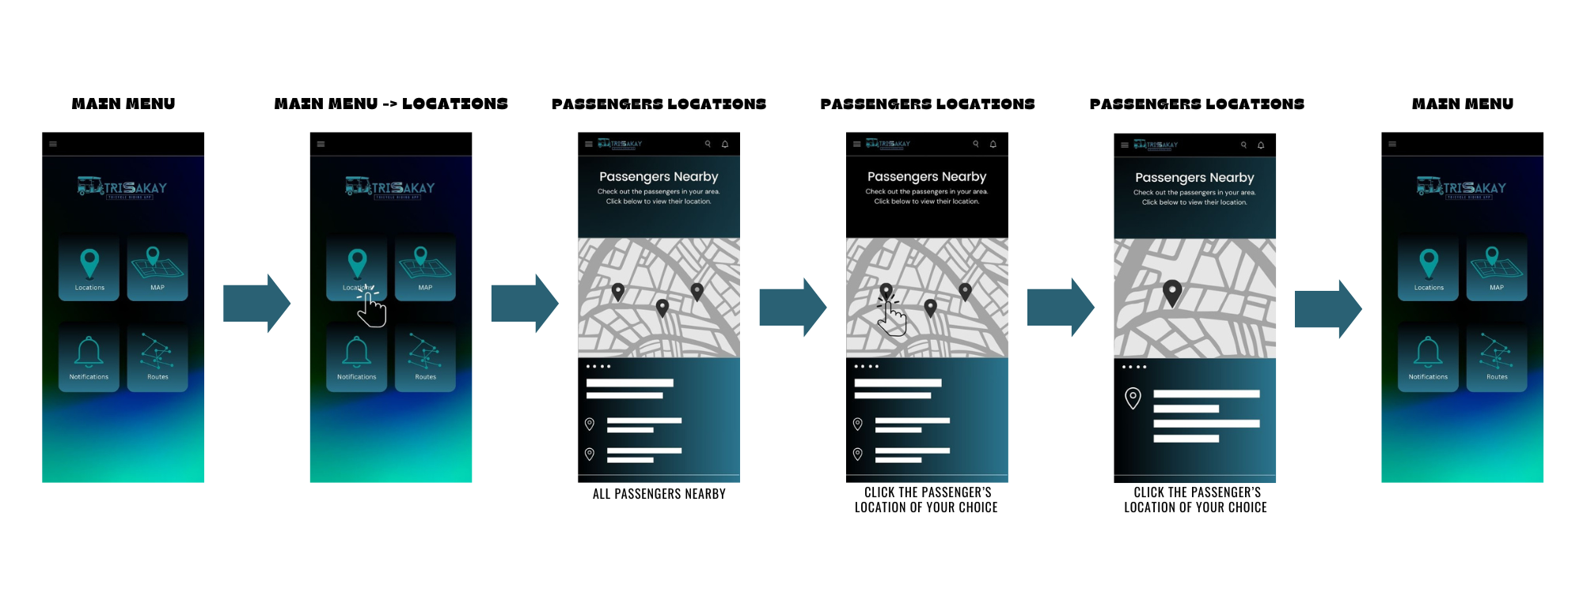**Figure 3. -** *Figure 3 shows the process of what a user undergoes from after logging into the app. The main menu screen is then in view by the user and once they click on locations, it will either show the broad and specific locations of drivers nearby or passengers nearby.*

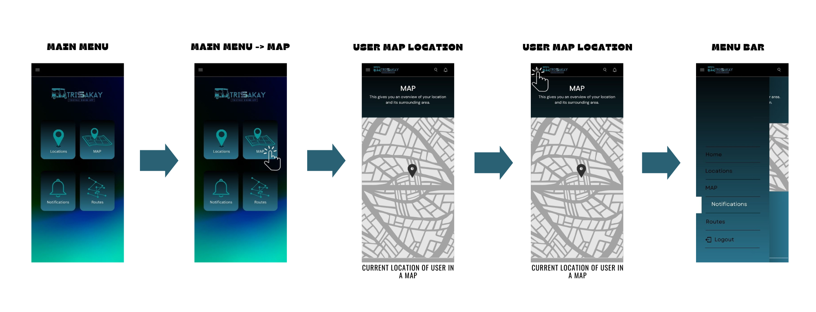**Figure 4. -** *Figure 4 shows the process of what a user undergoes once they click on MAP from the main menu screen. It will then show a whole map overview of the user's location. It also shows the neat feature of the menu bar to change pages as well.*

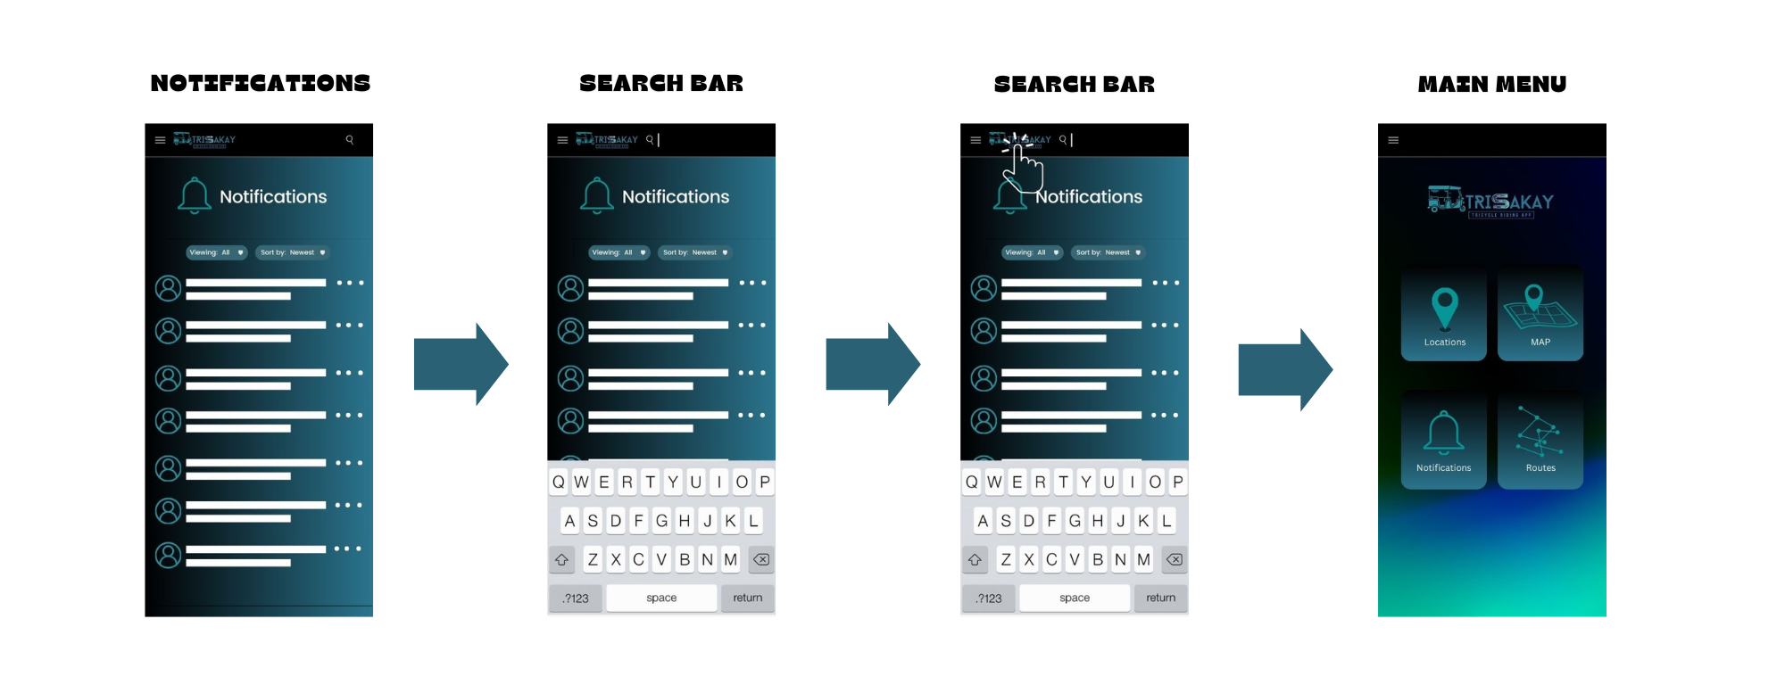**Figure 5. -** *Figure 5 shows the process of what a user undergoes after clicking on notifications either from the main menu or from the menu bar. The notifications page shows each user real-time notifications that are happening within the app. A search bar and sorting dropdown box are also located within the notifications page to help user search for specific notifications/messages and arrange notifications/messages according to their liking. The feature of clicking the logo of the app also directs a user back to the main menu.*

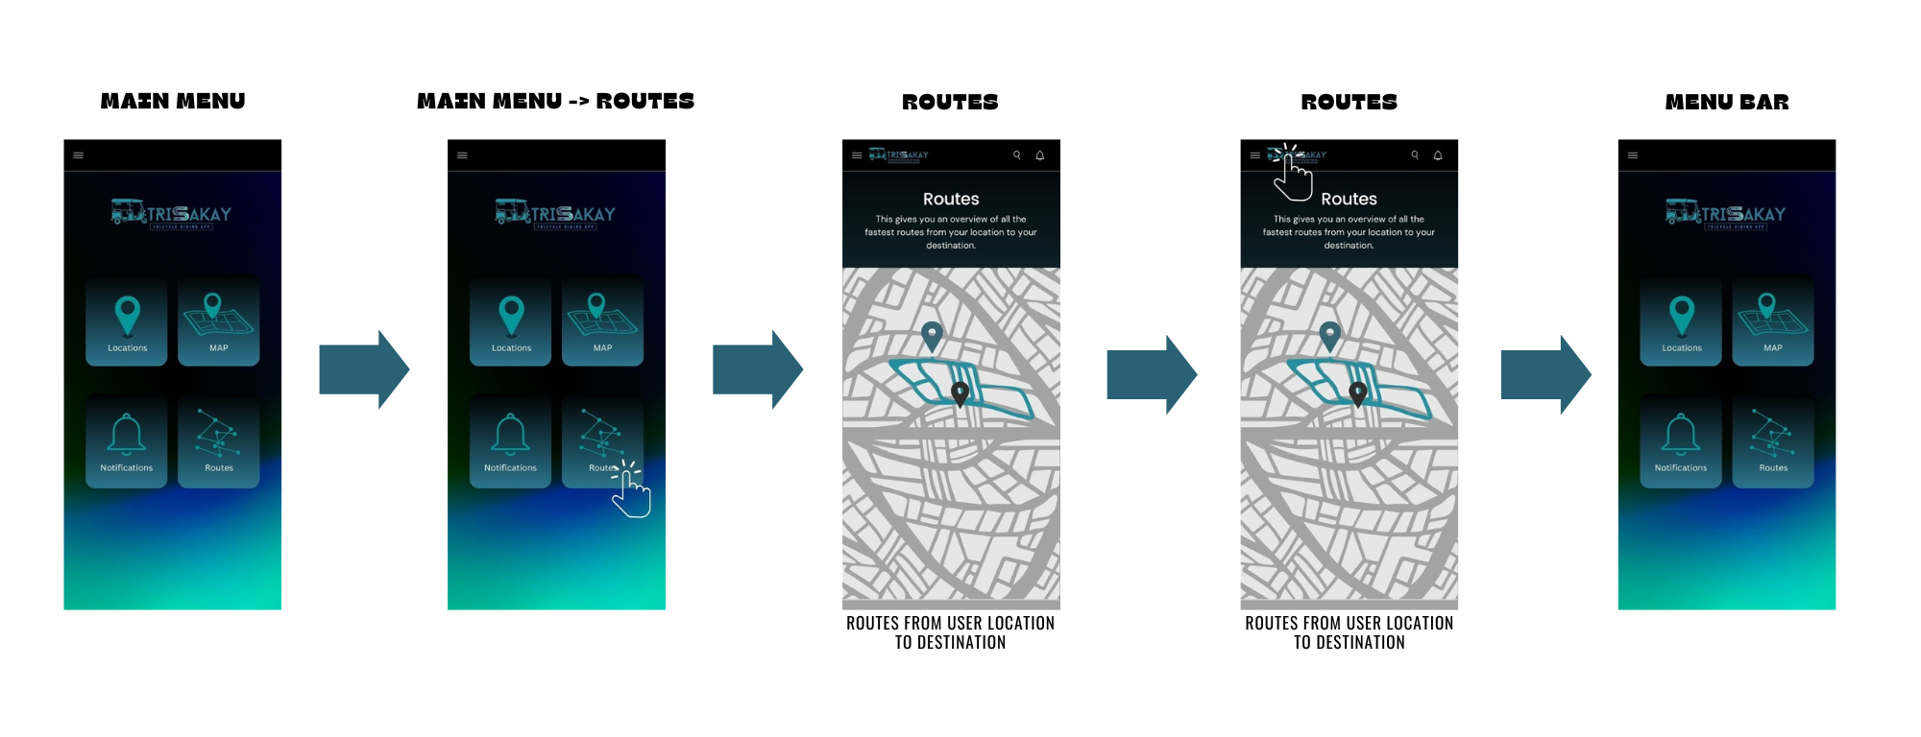**Figure 6.** *- Figure 6 shows the process of what a user undergoes from clicking the routes category in the main menu page. The routes page shows the user different routes they can take, if ever they want to choose on taking the longest, quickest, etc. different routes given and shown on their screen, personalized for them based off of their specific locations and destinations.*

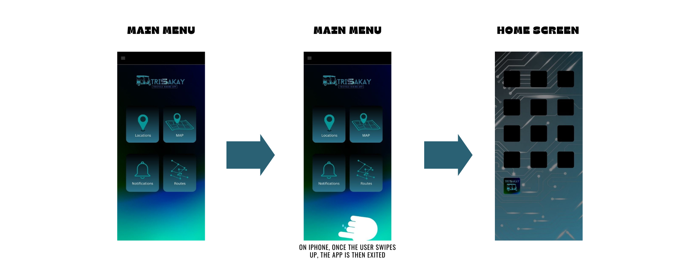**Figure 7. -** *Figure 7 shows the process of what a user will undergo once they either swipe up (for iPhone; also varying on different devices) for the action of allowing the app to exit/close and return to the users’ home screen.*

**Rationale:**

The team has selected to use Canva to illustrate the process used to make this prototype since it is a free graphic design platform that provides tools for creating websites, presentations, etc. It also enabled the team to pioneer this app in presenting the application's tentative final design to their users. Likewise, Canva is also a highly practical software for creating, presenting, or even sharing (prototype) designs with people/users, whether they are in person or not. It is also quite easy to update and alter after receiving feedback. Hence, that is not to imply that Canva is perfect; in order to save changes, the user must have an ongoing internet connection, which prevents them from quitting the software application if they do not have one. Limited icons, figures and even premium ones are some limitations and challenges within the use of this app.

**Changes to the Requirements:**

The system requirements remained the same throughout this project's journey, but the prototype had other extra and missed out features it could have included and improved beforehand. To address the query, "How could this prototype be easygoing yet maximize every needed feature?", this was one question we could ponder on to make an efficient yet user friendly application, thinking about the user's perspective and focused on their needs. Thus, the aim of the production regarding this project was to make the prototype as simple to use as possible for every user to encounter it and so that each user would benefit from the app and not be confused while using it.

**Population**

Around 10 to 15 chosen participants will view the prototype. They will have to view the prototype flow video provided to better understand the basic way the app goes and functions as. For the TriSakay prototype to be considered as completed, it would need to fulfill the specified requirements and criteria.

Roles

For this evaluation, the team will bring in a minimum of ten individuals. Considering this, the team will divide the population and be assigned to corresponding duties for the evaluation.

|  |  |
| --- | --- |
| **Developer / UI Designer Member** | **Task(s)** |
| Reynette Micah Lagat | Will be gathering users' evaluations about the prototype users, taking notes about the user's experience and communicating with the team about the data collected completed by each participant. |
| David Anthony Sian | Will be gathering users' evaluations about the prototype users, taking notes about the user's experience and communicating with the team about the data collected completed by each participant. |

Table 2. Team Member Evaluation Tasks

# Heuristic Evaluation

The evaluation of TriSakay will also be using Nielsen’s 10 Heuristic methods of Evaluation.

*Visibility of System Status*

* The system design provides appropriate feedback like message prompts in response to user actions.
* The message prompts are clear, visible and understandable.

## Match Between System and Real World

* Used words, phrases and concepts according to users’ language rather than system-oriented words and computer jargon.

## User control and Freedom

* The system design provides ways of allowing users to easily “get in” and “get out” if they find themselves in unfamiliar parts of the system.

## Consistency and Standards

* The colors, text, labels, buttons and other elements in the design are uniform from start to finish**.**
* Text and icons are not too small or too big.
* Menus and other features of the system are arranged and positioned in a consistent way. (For ex. If your website has navigation buttons on the top under the page title on one page, the users will automatically look there for the same features on other pages.

## Error Prevention

## The system design provides automatic detection of errors and prevents them from occurring in the first place.

* Idiot proofing mechanisms are applied

## Help Users Recognize, Diagnose, and Recover from Errors

* Error messages and the terms used are recognizable, familiar and understandable for the users.

## Recognition rather than recall

## Objects, icons, actions and options are visible for the user.

## Objects are labeled well with text and icons that can immediately be spotted by the user and matched with what they want to do.

## Flexibility and Efficiency of Use

* The system design provides easy to navigate menus.
* The system does not waste time of system resources.

## Aesthetic and Minimalist Design

* The graphics and animations used are not difficult to look at and do not clutter (mess) up the screen.
* The information provided is relevant and needed for the system design.

## Help and Documentation

* The system design provides information that can be easily searched and provides help in a set of concrete steps that can easily be followed.

# Participant Survey and Feedback

**After conducting through providing the online survey questionnaire,**

|  |  |
| --- | --- |
| **DATA GATHRERING METHOD** | **DESCRIPTION** |
| Survey (Quantitative) | Following the online evaluation, the participants will get a survey from the team collecting data on their experience viewing the prototype. This data will be interpreted by the team using a 5-point Likert scale, as shown in **Table 5. 5-Point Likert Scale Interpretation**. |
| Feedback (Qualitative) | To allow the participants/users voice out any problems or issues with the prototype that need to be resolved, or even positive feedback, the team's survey will contain a **Feedback section** at the end of the questionnaire. |

Table 3. Data Gathering Methods

The table above showcases the two (2) different data gathering methods the team will be using while providing the online evaluation form about the TriSakay Prototype.

|  |  |  |
| --- | --- | --- |
| **Question** | **Method of Answer** |  |
| **Section 1 - 5-point Likert Scale** | |  |
| Participant Number | Short Answer |  |
| 1. Visibility of System Status  * - The system design provides appropriate feedback like message prompts in response to user actions.   - The message prompts are clear, visible and understandable. | 5-Point Scale  5-Point Scale |  |
| 1. Match between the system and the real world   - Used words, phrases and concepts according to users’ language rather than system-oriented words and computer jargons. |
| 1. User control and freedom   - The system design provides ways of allowing users to easily “get in” and “get out” if they find themselves in unfamiliar parts of the system. |
| 1. Consistency and Standards  * - The colors, text, labels, buttons and other elements in the design are uniform from start to finish.   - Text and icons are not too small or too big.  - Menus and other features of the system are arranged and positioned in a consistent way. (For ex. If your website has navigation buttons on the top under the page title on one page, the users will automatically look there for the same features on other pages. |
| 1. Error Prevention   - The system design provides automatic detection of errors and prevents them from occurring in the first place.  - Idiot proofing mechanisms are applied |
| 1. Help users recognize, diagnose and recover from errors   - Error messages and the terms used are recognizable, familiar and understandable for the users. |
| G. Recognition rather than recall  - Objects, icons, actions and options are visible for the user.  - Objects are labeled well with text and icons that can immediately be spotted by the user and matched with what they want to do. |
| H. Flexibility and efficiency of use  - The system design provides easy to navigate menus.  - The system does not waste time of system resources. |
| 1. Aesthetic and minimalist design   - Graphics and animations used are not difficult to look at and do not clutter (mess) up the screen.  - Information provided is relevant and needed for the system design. |
| 1. Help and Documentation   - The system design provides information that can be easily searched and provides help in a set of concrete steps that can easily be followed. |
| **Section 2: Feedback Section** | |  |
| What is your experience with viewing the prototype flow? Has it achieved the desired system flow? | Short Answers |  |
| What impressions do you have of the prototype's user interface as you viewed the navigation flow? | Short Answers |  |
| User Feedback | Short Answers |  |

Table 4. Survey/Feeback Questionnaire

The questions included in the survey for this prototype are shown in the table above. After have been made by the team through Googe Forms, participants will get this survey via a link. The questionnaire survey may still be accessible up till now. By clicking the link, it shall direct you striaght to it. --> <https://forms.gle/E2BVGwr47KcsPDxq5>

|  |  |  |  |  |
| --- | --- | --- | --- | --- |
| **Scale** | **Range Value** | **Interpretation** | | **Classification** |
| 5 | 4.50-5.00 | Very Good | | Successful |
| 4 | 3.50-4.49 | Good | |  |
| 3 | 2.50-3.49 | Acceptable | | Neutral |
| 2 | 1.50-2.49 | Poor | | Unsuccessful |
| 1 | 1.00-1.49 | Very Poor | |  |

Table 5. 5-Point Likert Scale Survey Interpretation

The interpretation of the survey questions provided to the participants is shown in Table 5. The survey results will be used to determine if the layout, design, features and functions are beneficial to the users who have encountered the TriSakay prototype.